**FINAL PROJECT**

**GitHub Repo URL  :** [**https://github.com/lakshmimadhan9794/capstone.git**](https://github.com/lakshmimadhan9794/capstone.git)

**Deployed URL :**

**Jenkins :** <http://3.88.106.13:8080/login?from=%2F>

**Prometheus :** <http://44.206.241.67:9090/graph?g0.expr=&g0.tab=1&g0.stacked=0&g0.show_exemplars=0&g0.range_input=1h>

**Grafana :** <http://44.206.241.67:3000/?orgId=1&from=now-6h&to=now&timezone=browser>

**Docker image :** <http://44.206.241.67:8081/>

**Images name : latest   -    react-nginx**

**Screen Shot : Jenkins**

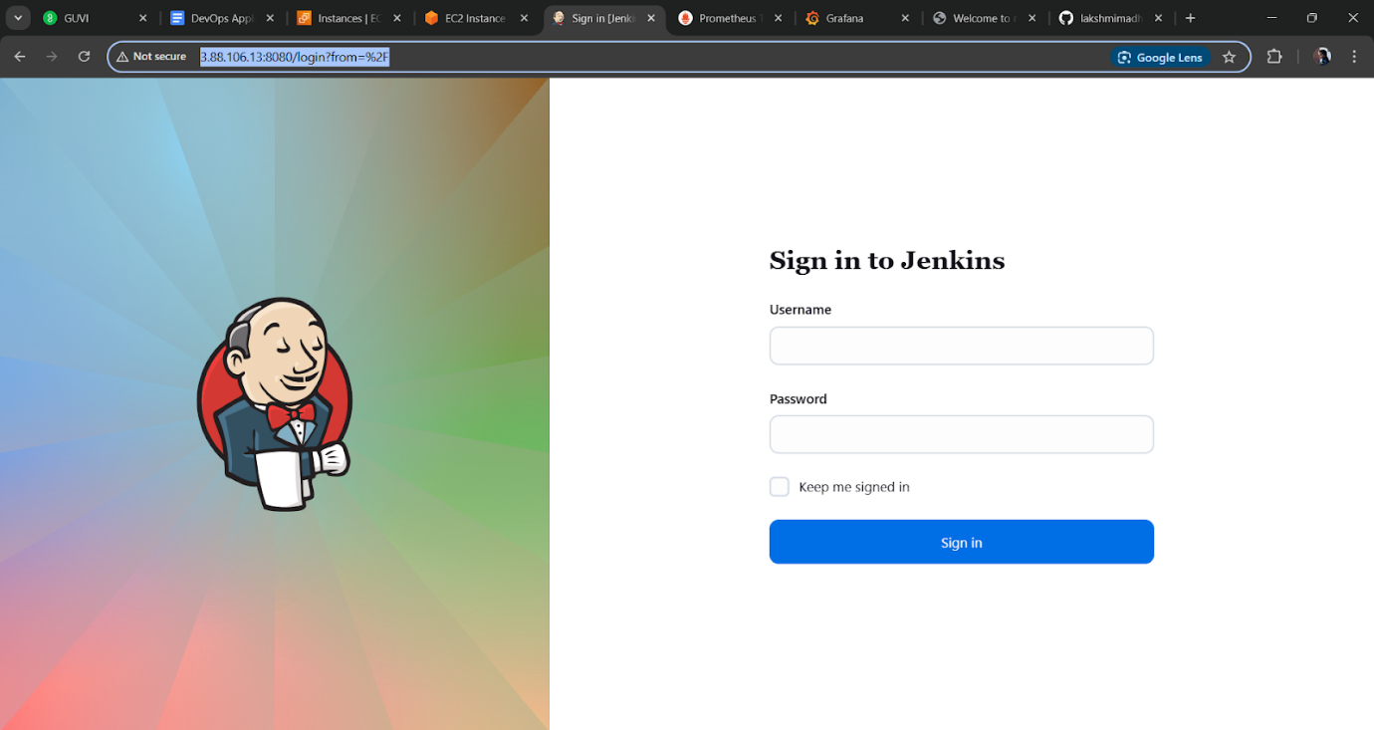

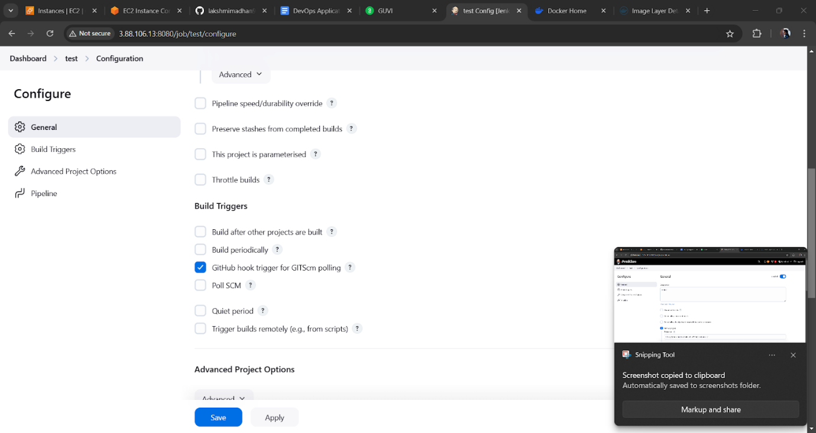

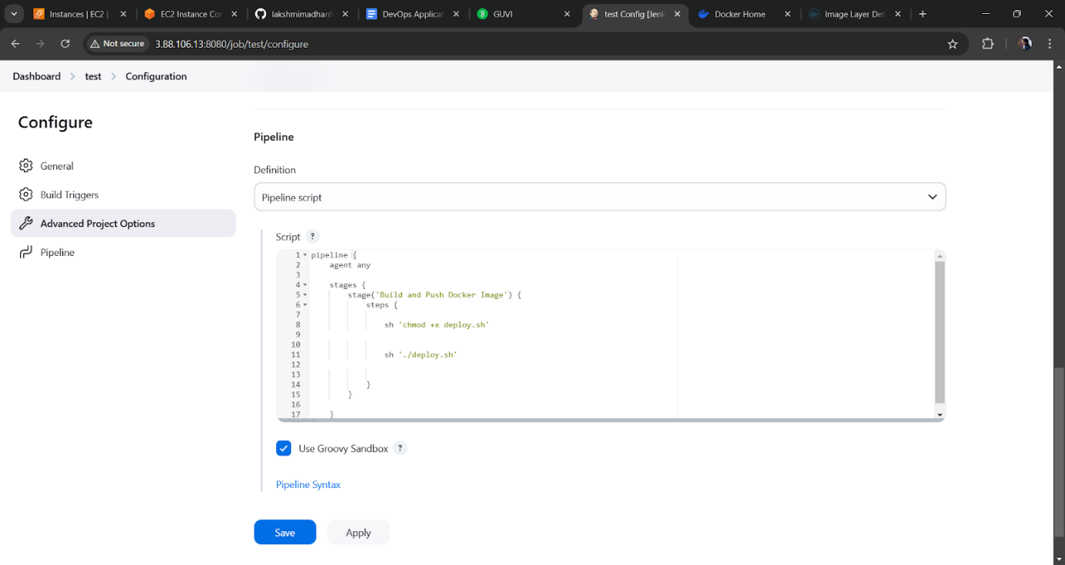

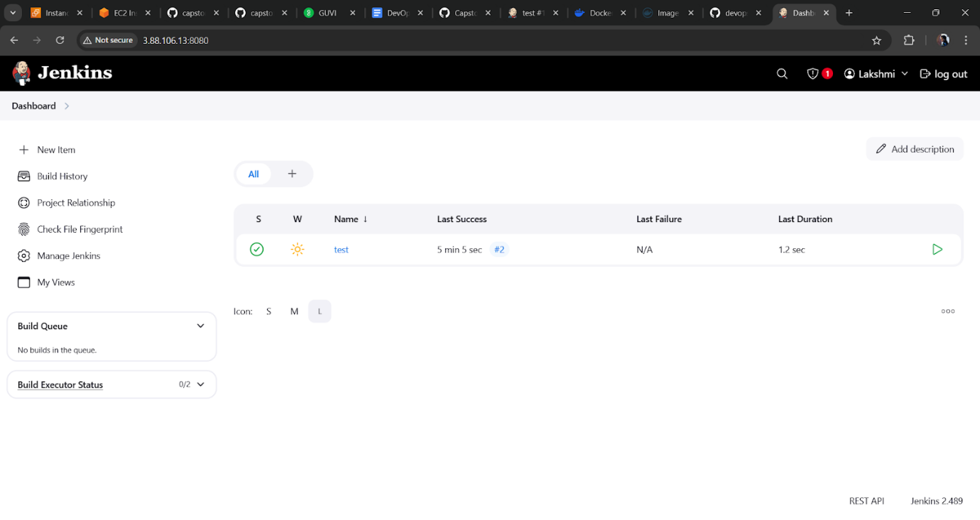

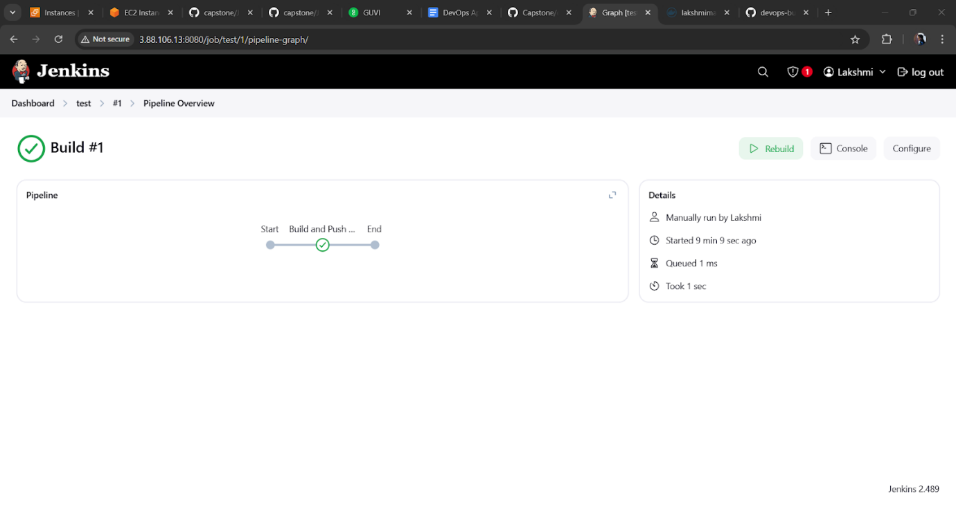

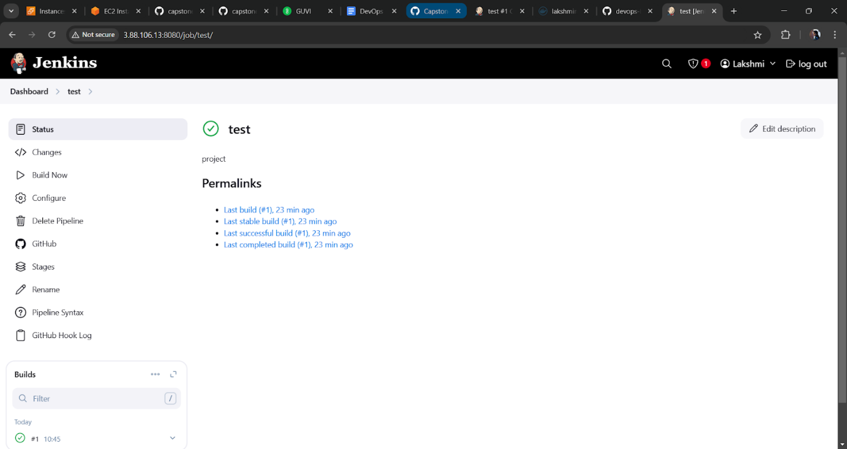

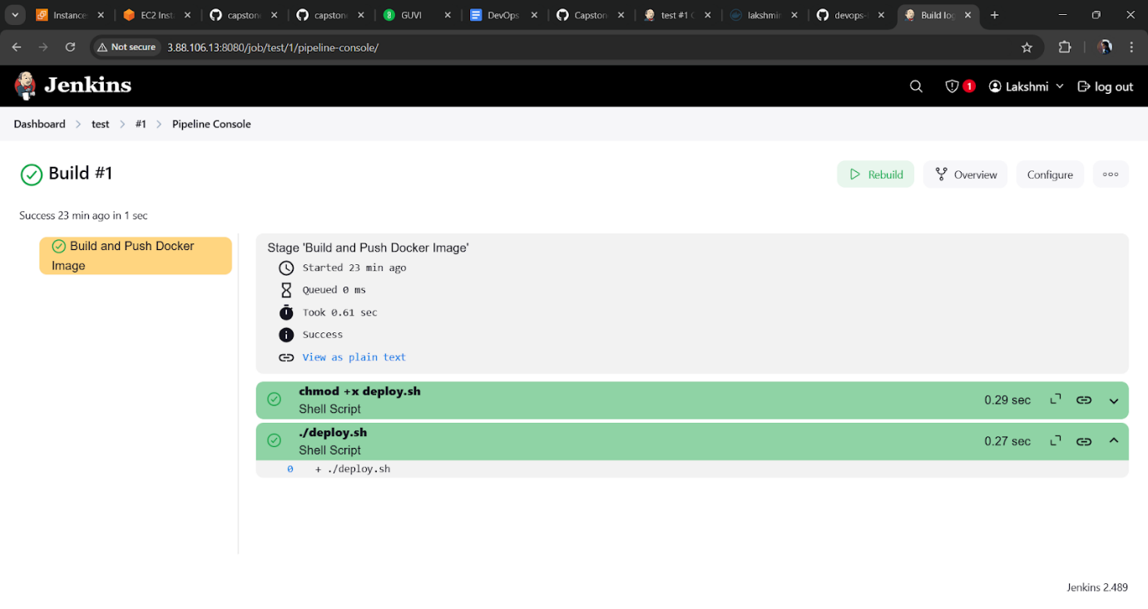

**DOCKER HUB :**

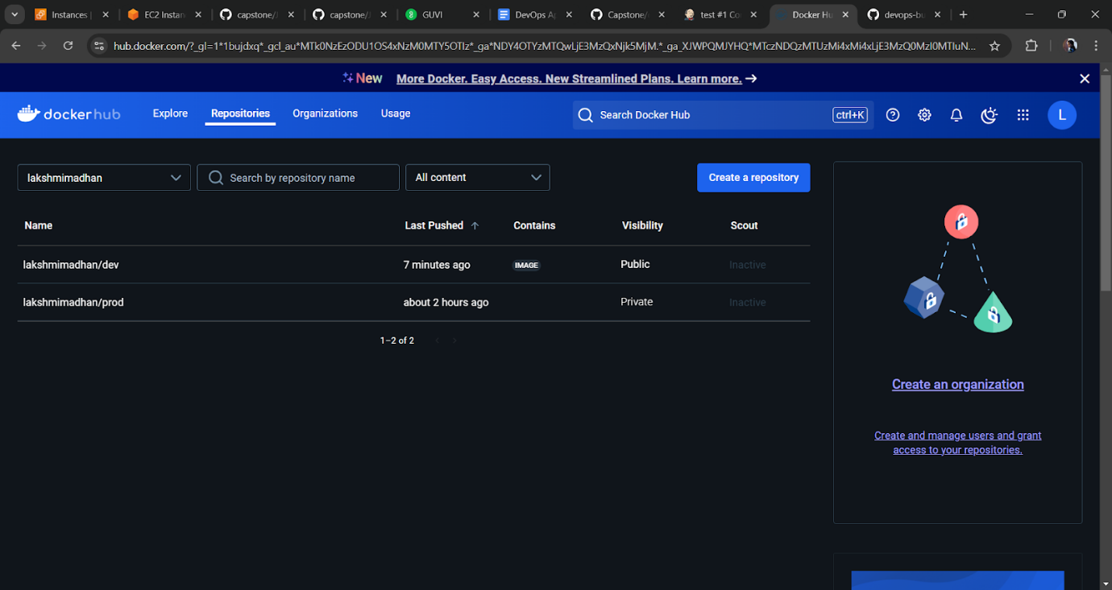

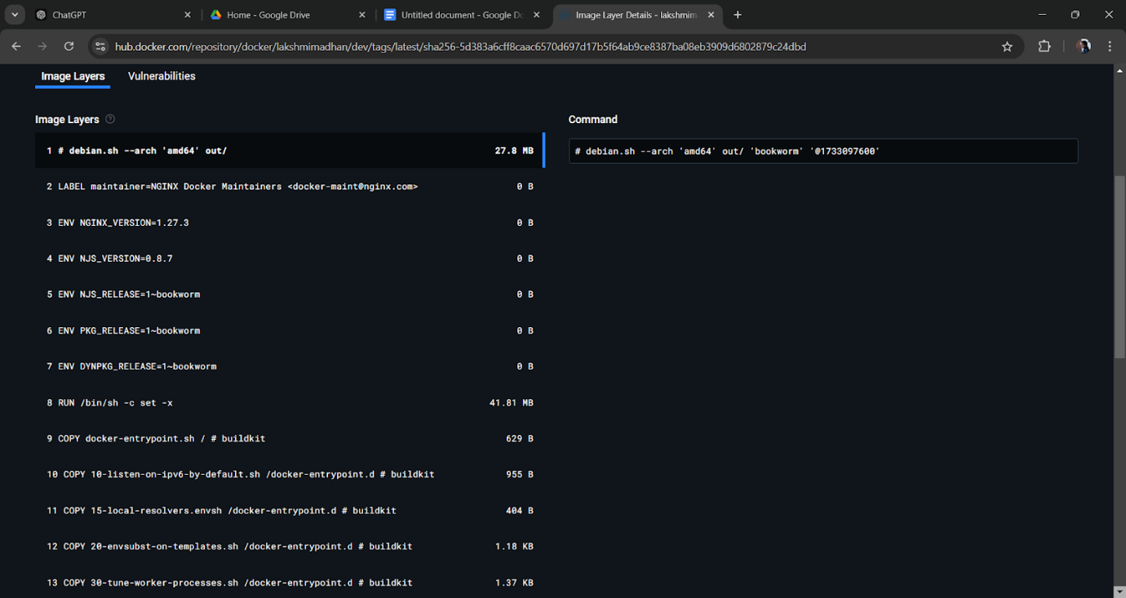

**EC2 Cosole :**

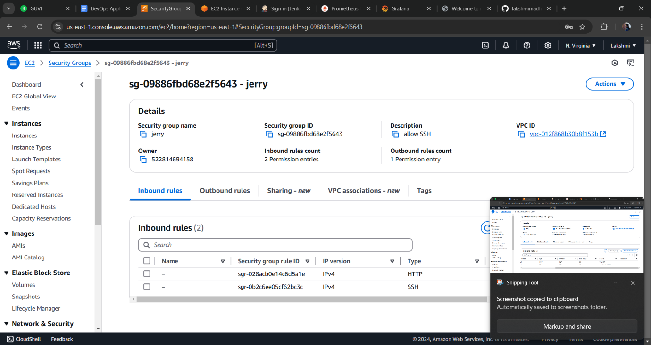

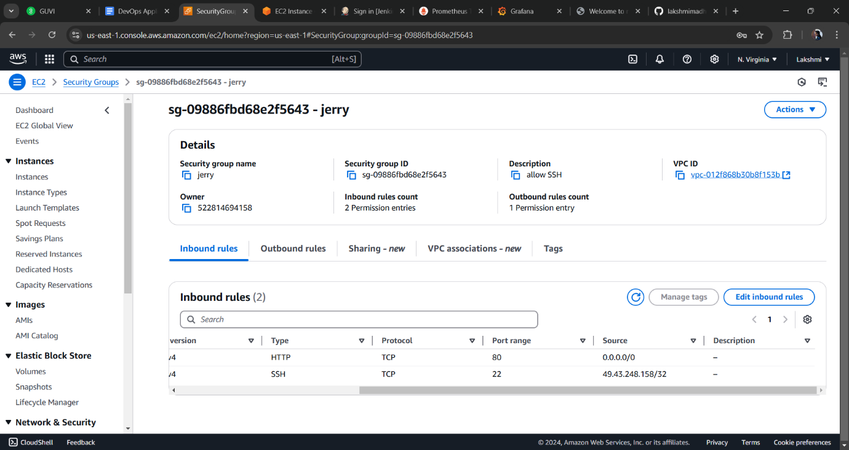

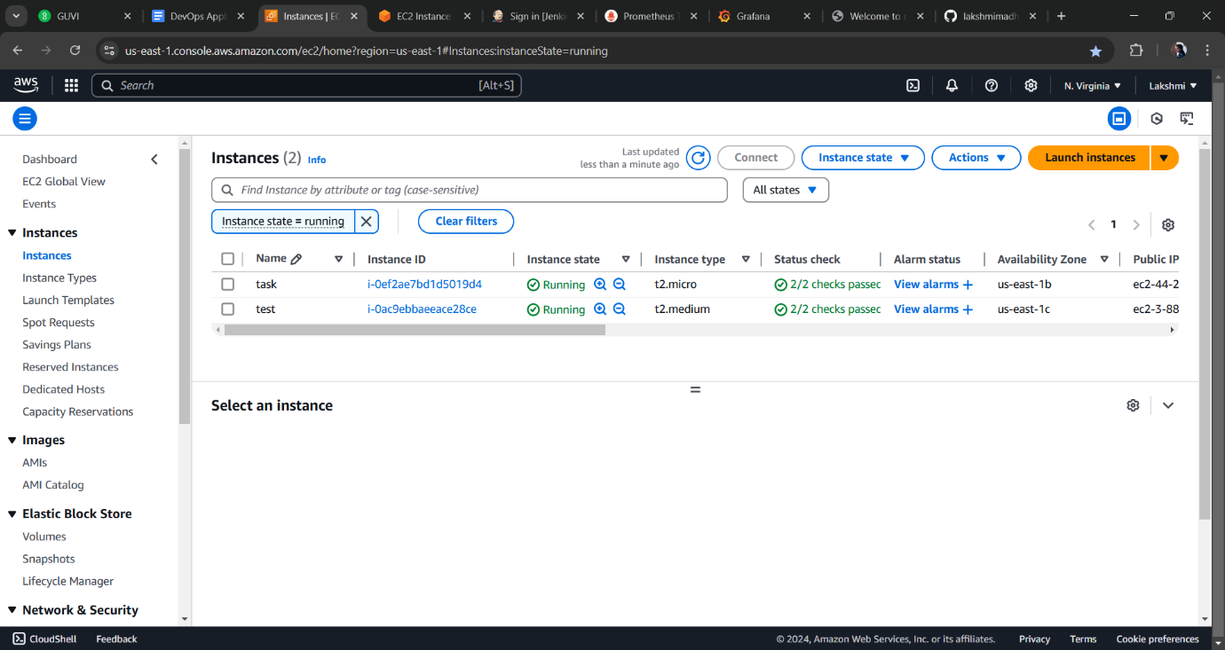

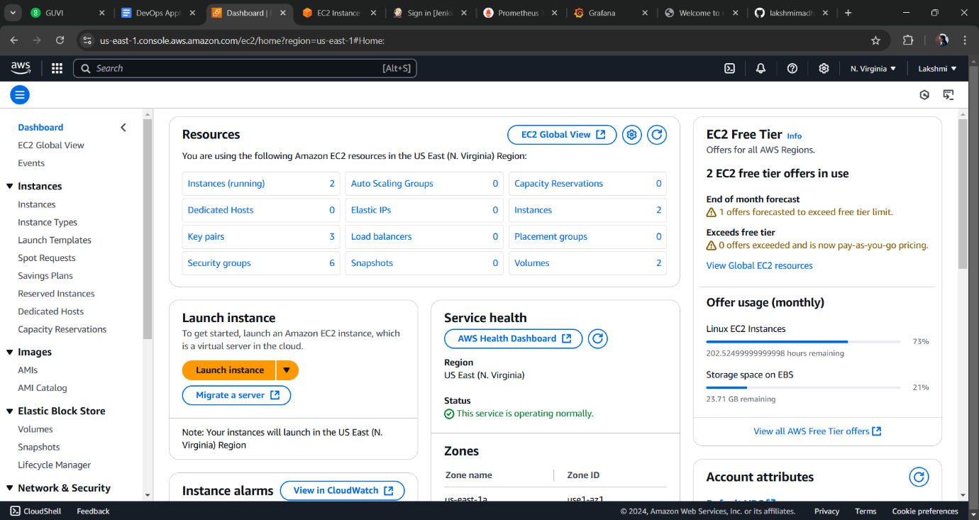

**Deploy site page :**

